SDG 3c occupations density

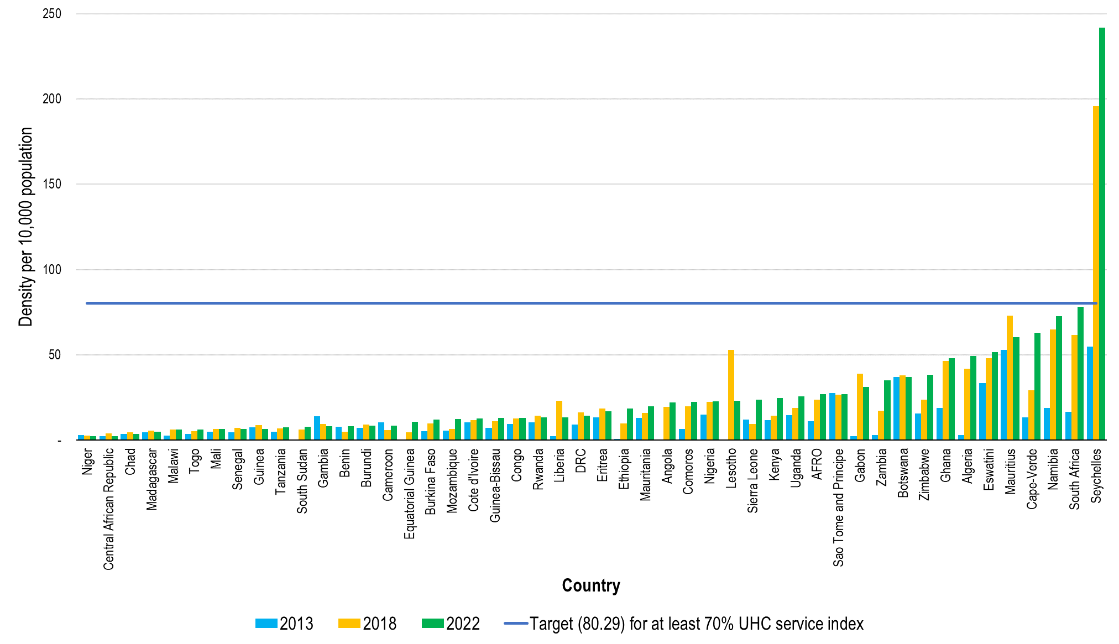
Figure xx: The density of the SDG 3c occupations between 2013 and 2022

x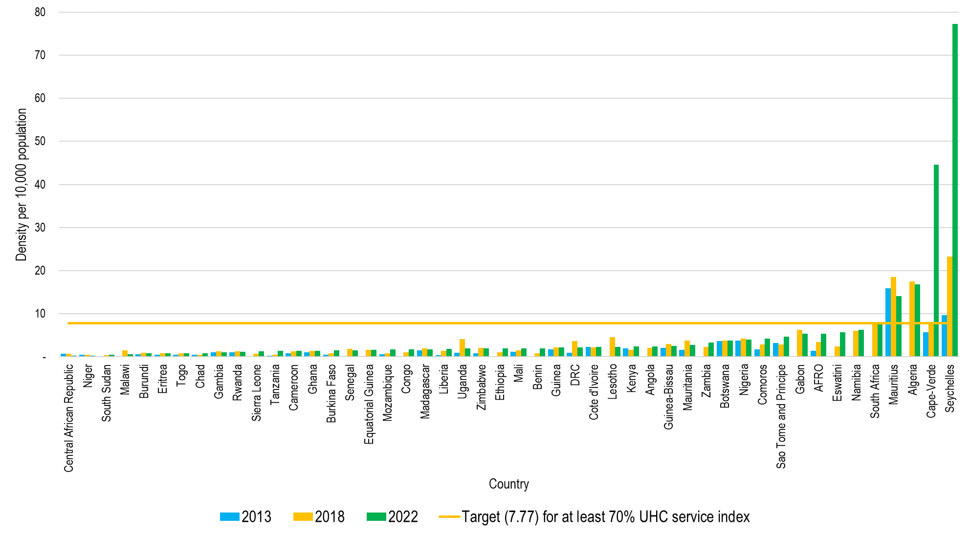
Figure XXX : The density of Medical doctors(Generalists and specialist) between 2013 and 2022

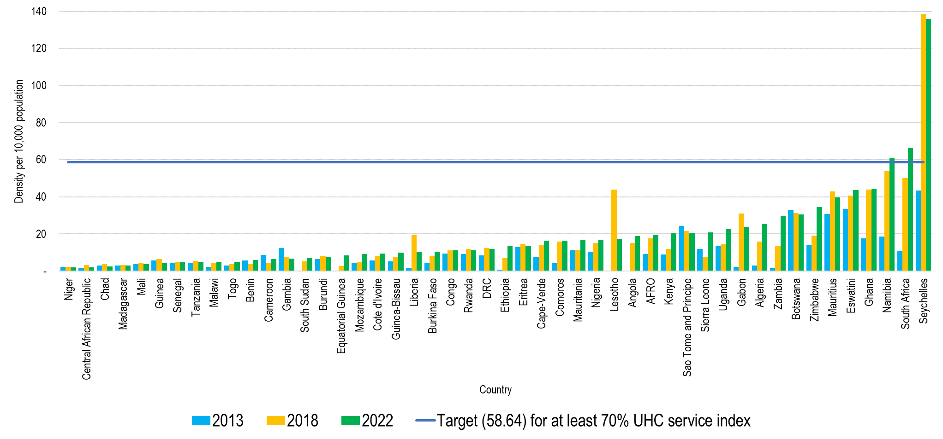
Nurses and midwives

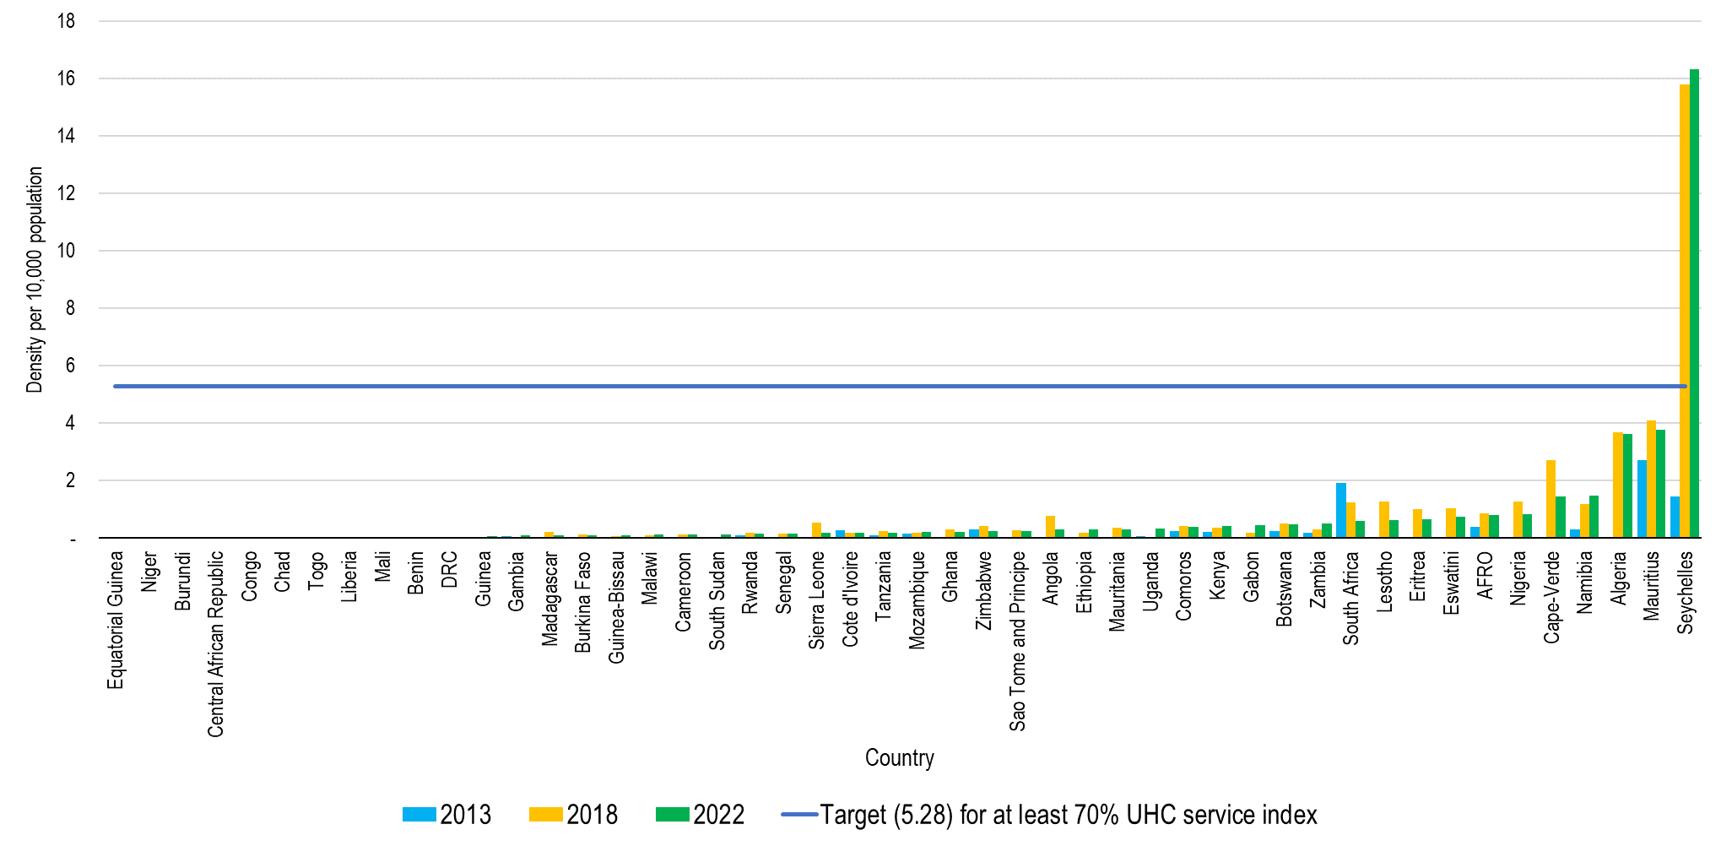
Dentists and Dental Assistants/Therapists

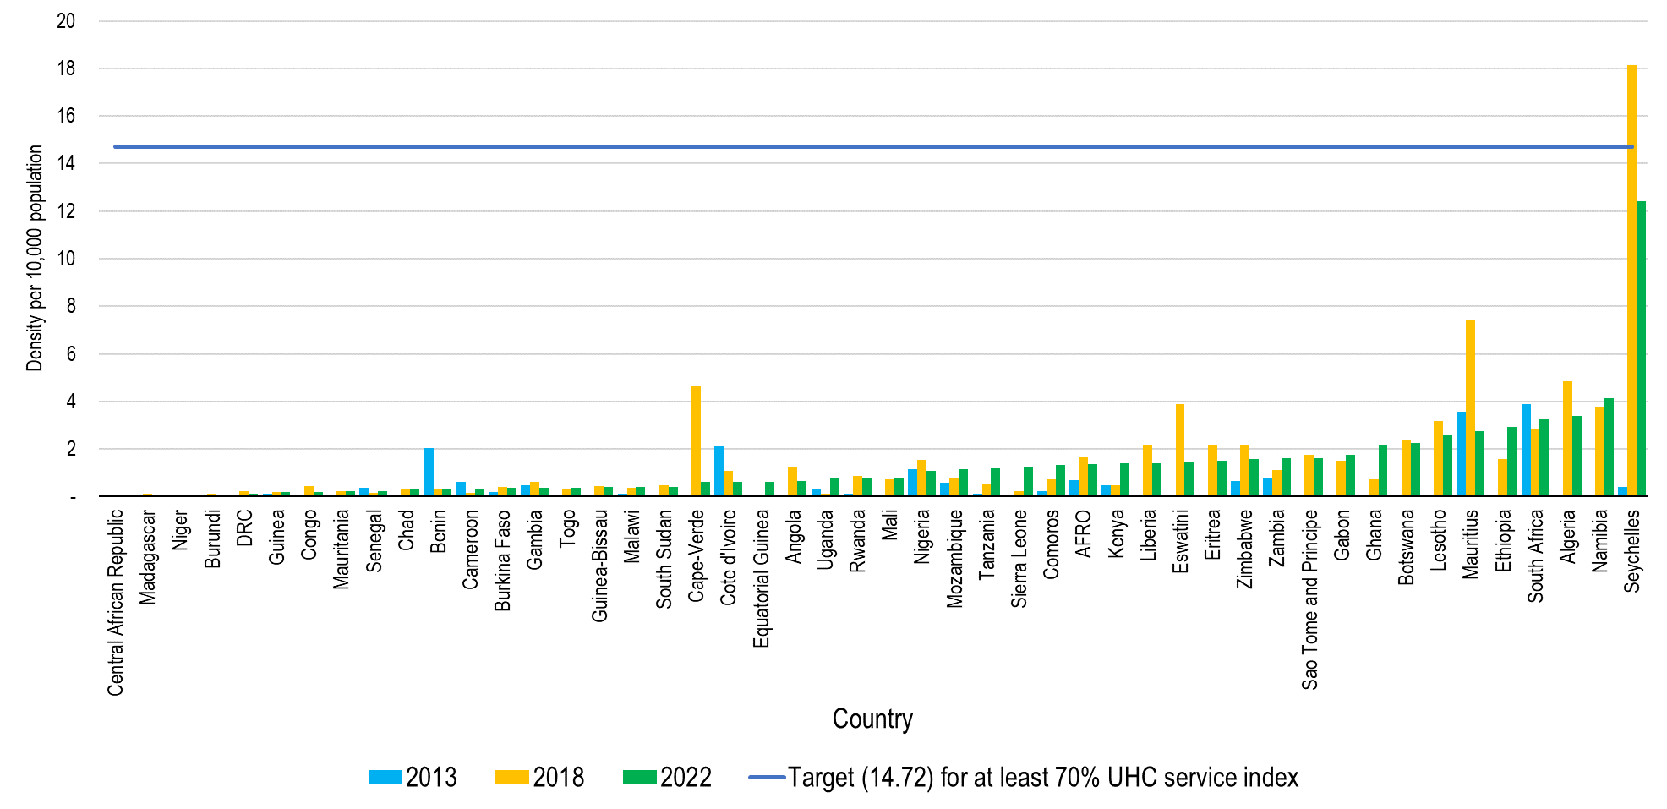
Pharmacists and Pharmaceutical Technicians/Assistants

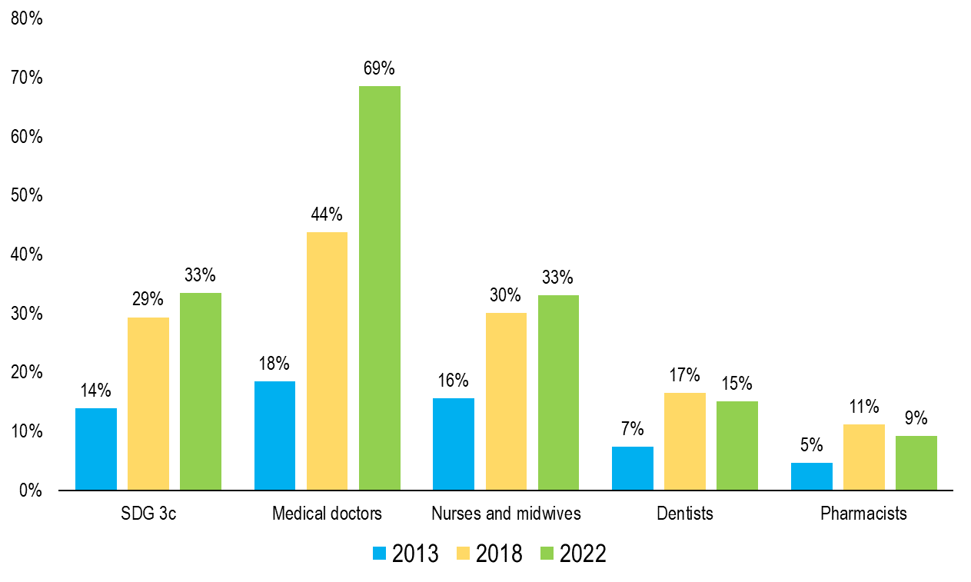
Figure XX: Percentage of the achieved densities for the realization of at least 70% UHC service coverage

Note: in 2022 the African region was at 33% of the required densities for the attainment of atleast 70% UHC service coverage from 14% in 2013. The medical doctors had the highest achievement (69% on average of the required density) and the least were the pharmacists (at 9%, which was a drop from 11% in 2018).

